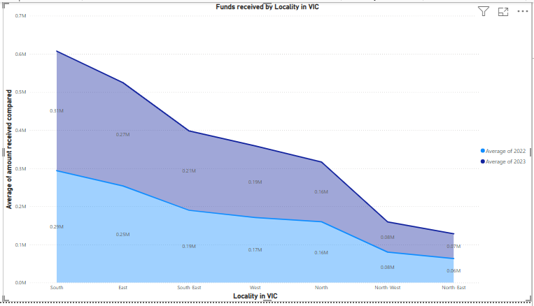 Funds received by Suburbs in VIC for 22,23

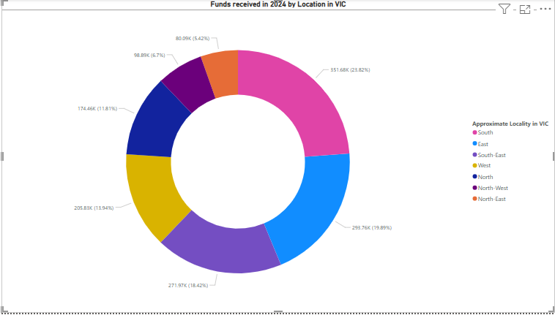 Funds received by Suburbs in VIC for 24

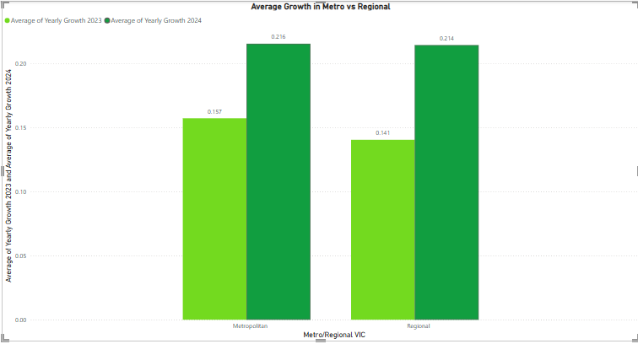Average of Growth in Metro Areas vs Regional Areas

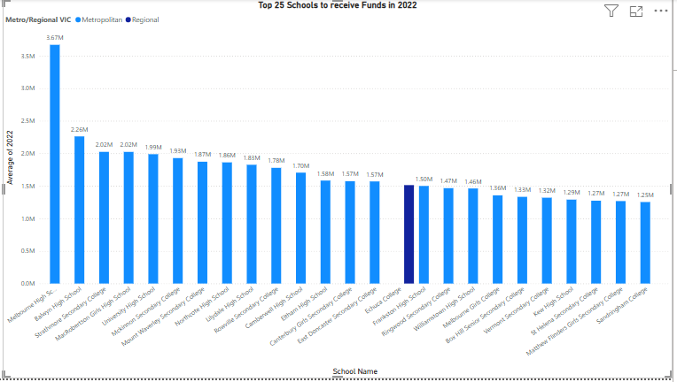 Top Schools in 22

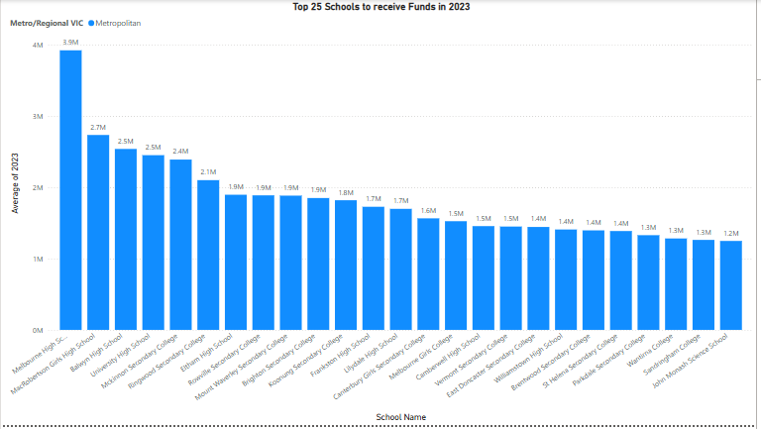 Top Schools in 23

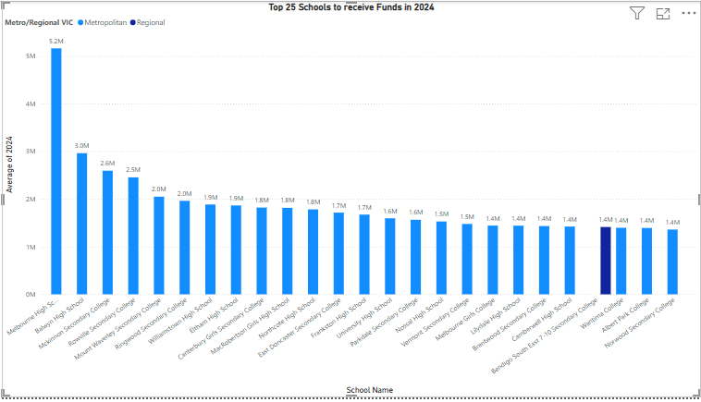 Top School in 24

